Insert school header here

Semester Two Examination, 2014

Answer key

CHEMISTRY
Stage 3

Section One: Multiple-choice 25% (50 marks)

1 | B | 14 | D
2 | A | 15 | A
3 | D | 16 | A
4 | C | 17 | D
5 | B | 18 | C
6 | C | 19 | B
7 | D | 20 | A
8 | A | 21 | D
9 | C | 22 | C
10 | B | 23 | B
11 | D | 24 | D
12 | C | 25 | A
13 | B

Section Two: Short answer 35% (70 Marks)

This section has nine (9) questions. Answer all questions. Write your answers in the space provided.

When calculating numerical answers, show your working or reasoning clearly. Express numerical answers to three significant figures and include appropriate units where applicable.

Spare pages are included at the end of this booklet. They can be used for planning your responses and/or as additional space if required to continue an answer.
- Planning: If you use the spare pages for planning, indicate this clearly at the top of the page.
- Continuing an answer: If you need to use the space to continue an answer, indicate in the original answer space where the answer is continued, i.e. give the page number. Fill in the number of the question(s) that you are continuing to answer at the top of the page.

Suggested working time: 60 minutes.

Question 26 (5 marks)

The graph below shows the distribution of energies amongst particles in a sample of gas at a particular temperature, T₁.
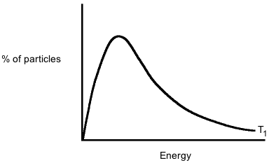

- Add a line to the graph to show how the distribution would be expected to change if the temperature was raised to some new temperature, T₂. (2 marks)

Peak drawn at higher energy (but lower %) ✔
Line continues at higher energy and does not cross T₁ line for a second time ✔

- Use the graph, and your understanding of collision theory, to explain why relatively small increases in temperature can lead to quite large increases in the rates of chemical reactions.
(3 marks)
Area under curve to the right of red line (some energy marked on graph) is much greater at higher T ✔
Hence much greater % of particles have enough energy to react ✔
Hence many more successful collisions per sec ✔

Question 27 (10 marks)

By referring to the structure and/or bonding present, account for the following:

- Graphite has an extremely high melting point (3727°C), but is one of the softest minerals known, and is a good conductor of electricity in the solid state. (4 marks)

Graphite is a covalent network (made up of layers of covalently bonded atoms ✔
Strong covalent bonds between atoms give rise to high melting point ✔
Weak forces between layers mean its shape can easily be changed, making it soft ✔
Delocalised electrons between layers allow it to conduct ✔

- When hit with a hammer, solid magnesium will dent but not break, whilst solid magnesium chloride will fracture. (4 marks)

In magnesium, ions are arranged in a metallic lattice surrounded by delocalized electrons ✔
Metallic bonds not broken when magnesium is struck, since electrons can move ✔
Magnesium chloride has oppositely charged ions in a lattice ✔
Striking the lattice can bring like charged ions into contact, and these repel, causing the material to fracture ✔

- Moving across the period 3 elements from left to right, we observe a gradual decrease in atomic radius. (2 marks)

Nuclear charge increases from left to right, whilst number of shells is unchanged ✔
Attraction of outer shell towards nucleus increases, drawing it towards the nucleus ✔
Question 28 (11 marks)

The diagram below shows an electrochemical cell made using a nickel rod dipped in a
1.00 mol L⁻¹ solution of nickel sulfate at one electrode and a magnesium rod dipped in a
1.00 mol L⁻¹ solution of magnesium sulfate at the other. The relative charge of the electrodes is indicated on the diagram.

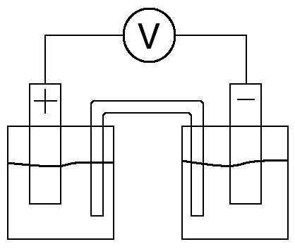

- Label the diagram to show the following:

- Which metal is at each electrode
- The direction of electron flow in the external circuit
- The direction of ion flow in the salt bridge
- The anode and cathode (4 marks)

Metals at correct electrodes (Magnesium is the negative) ✔
Electrons flowing from negative to positive ✔
Positive ions flowing from left to right (or negative from right to left) ✔
Anode and cathode correctly identified (cathode is negative) ✔

A half cell can be constructed in which there is an equilibrium consisting of solid manganese dioxide (MnO₂) and Mn²⁺(aq) ions. When connected to a standard hydrogen electrode, this half cell is found to have a reduction potential of +1.29 V.

- State the significance of the sign of this reduction potential in relation to the standard hydrogen electrode. (1 mark)

Manganese dioxide is a better oxidizing agent/more easily reduced than H⁺

Another electrochemical cell was made using an electrode made of a copper rod dipped in a 1.00 mol L⁻¹ solution of tin(II) sulfate, and connected to the MnO₂/Mn²⁺ half cell.

- In the table below, write balanced half equations to show the reactions taking place in each half cell. (3 marks)

Half cell | Half equation
Sn(s)/SnSO₄(aq) | Sn Sn²⁺ + 2e⁻ ✔
MnO₂(s)/Mn²⁺(aq) | MnO₂ + 4H⁺ + 2e⁻ Mn²⁺ + 2H₂O  Correct species ✔  Balanced ✔

- Calculate the cell potential, E°, that would be expected for this electrochemical cell. (1 mark)

+1.29 - (-0.14) = 1.43 V ✔

- Give TWO reasons why the actual measured cell potential might deviate from the value calculated in d). (2 marks)

Temperature not 25°C ✔
Concentrations of solutions not 1 mol L⁻¹ ✔

Question 29 (9 marks)

For each species listed in the table below, draw the Lewis structure, representing all valence shell electron pairs either as : or as — and state or sketch the shape of the species.

(for example, water |  | or |  | or |  | bent)
Species | Lewis structure (showing all valence electrons) | Shape (sketch or name)
Nitrite Ion  NO₂⁻ | 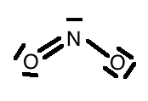 | Bent/non-linear/v-shaped
Silicon tetrachloride  SiC₄ | 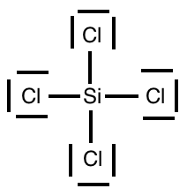 | Tetrahedral
Carbon disulfide  CS₂ | 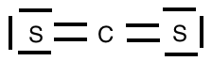 | Linear

Question 30 (6 marks)

The diagram below shows a section of a polymer widely used in packaging.

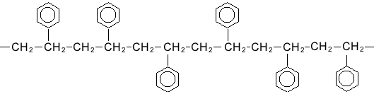

- What is the name given to the type of reaction used to make this polymer? (1 mark)

Addition

- In the space provided below, draw the structure of the monomer used to make this polymer.
(2 marks)

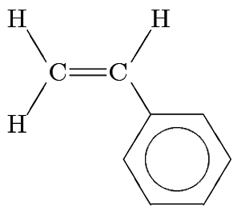
C=C double bond shown ✔
Correct groups attached to C=C ✔

The diagram below shows the structure of lactic acid.

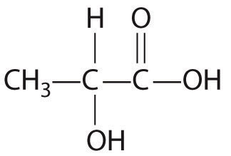

- In the space below, write an equation to show the reaction between THREE lactic acid molecules, making clear the structure of the organic product of the reaction. (3 marks)

3 CH₃CHOHCOOH HOCH(CH₃)COOCH(CH₃)COOCH(CH₃)COOH + 2H₂O

Ester functional groups correctly shown ✔
Correct formula of organic product ✔
Balanced ✔

Question 31 (5 marks)

The following diagram shows the structure of a tripeptide formed from the reaction between three different α-amino acids.
Group A

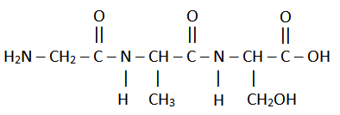
Group B

- On the diagram, circle the functional group that would be expected to react with a solution of sodium carbonate. Label this “group A”. (1 mark)

- On the diagram, circle the functional group that would be expected to react with a solution of hydrochloric acid. Label this “group B”. (1 mark)

Award mark if amide functional group is identified as group B

- What is the name given to the type of reaction used to produce this peptide from its α-amino acid monomers? (1 mark)

Condensation

- Tripeptides such as these are commonly observed to have a high solubility in water. Use the structure of the tripeptide shown above to explain this observation. (2 mark)

NH and/or OH groups identified as being the features that give rise to high solubility ✔
Hydrogen bonding occurs between these groups and water molecules ✔

Question 32 (8 marks)

The auto-ionisation of ammonia can be represented using the equation below.

2 NH₃ $⇌$ NH₄⁺ + NH₂⁻

- Explain the concept of Bronsted-Lowry conjugate acid-base pairs with reference to this equation. Your answer should identify any conjugate acid-base pairs present. (3 marks)

Conjugate pairs are species that differ by the presence/absence of 1H⁺ ✔
NH₄⁺ is the conjugate acid of ammonia ✔
NH₂⁻ is the conjugate base of ammonia ✔

Water is also capable of auto-ionisation, according to the following equation.

2 H₂O() $⇌$ H₃O⁺(aq) + OH⁻(aq)

- Given that pure water has a pH of exactly 7 at 25°C and that the forward reaction is endothermic, state and explain what effect heating water above 25°C will have on its pH.
(3 marks)

Heating the water will cause the forward (endothermic) reaction to be favoured ✔
[H₃O⁺] will increase ✔
pH will fall ✔

- Explain why water can always be considered neutral, in spite of the fact that it can have different values of pH. (2 marks)

Solutions will be neutral when [H₃O⁺] = [OH⁻], and ionization of water will always produce equal amounts of OH⁻ and H₃O⁺ ✔
pH = -log[H⁺], and [H⁺] depends on temperature ✔

Question 33 (10 marks)

The table below shows the pH of 0.100 mol L⁻¹ aqueous solutions of three acids.

Acid solution | pH
Ethanoic acid | 2.88
Phosphoric acid | 1.62
Nitric Acid | 1.00

- Use appropriate equations to explain the difference in pH between 0.100 mol L⁻¹ solutions of ethanoic and nitric acid. (4 marks)

HNO₃ H⁺ + NO₃⁻ (or HNO₃ + H₂O H₃O⁺ + NO₃⁻) since HNO₃ is strong ✔
[H⁺] = [acid] = 0.100 mol L⁻¹, and pH = -log[H⁺], so pH = 1 ✔
CH₃COOH + H₂O $⇌$ CH₃COO⁻ + H₃O⁺ (or CH₃COOH $⇌$ CH₃COO⁻ + H⁺) since ethanoic acid is weak ✔
[H⁺] << [acid], so [H⁺] << 0.100 and pH > 1 ✔

- Calculate the amount of water that would need to be added to 50 mL of a 0.100 mol L⁻¹ solution of nitric acid to raise its pH to 1.62. (3 marks)

If pH = 1.62, then [H⁺] = 10^{-1.62} = 0.0240 mol L⁻¹ = [HNO₃] ✔
c₁v₁ = c₂v₂, so (0.100 x 0.05) / 0.0240 = v₂ = 208 mL ✔
volume to be added = 208 – 50 = 158 mL ✔

Solutions of sodium dihydrogenphosphate (NaH₂PO₄) can be prepared by mixing sodium hydroxide with phosphoric acid. These solutions are able to act as buffers.

- Use appropriate equations to show how a solution of sodium dihydrogenphosphate is able to act as a buffer. (3 marks)

Acts as a buffer by reacting with any acid/base added to maintain pH ✔
H₂PO₄⁻ + H⁺ $⇌$ H₃PO₄ - absorbs acid ✔
H₂PO₄⁻ + OH⁻ $⇌$ HPO₄²⁻ + H₂O - absorbs base ✔
Question 34 (6 marks)

Complete the table by drawing the structure and giving the IUPAC name of the organic compounds that match each of the following descriptions.

Description | Structure | IUPAC name
A saturated secondary alcohol containing 10 hydrogen atoms | 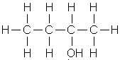 | Butan-2-ol (allow 2-butanol)
An ester that is an isomer of pentanoic acid and can react with NaOH(aq) to form ethanol | 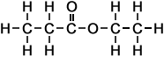 | Ethyl propanoate
A hydrocarbon that could be used to make 1,2-dichloromethylpropane via an addition reaction | 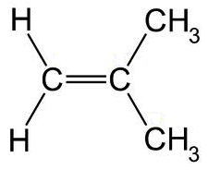 | Methylpropene (allow 2-methylpropene)

End of section two
Section Three: Extended answer 40% (80 marks)

This section contains six (6) questions. Answer all questions. Write your answers in the spaces provided.

Where questions require an explanation and/or description, marks are awarded for the relevant
chemical content and also for coherence and clarity of expression.

Final answers to calculations should be expressed to three (3) significant figures.

Spare pages are included at the end of this booklet. They can be used for planning your
responses and/or as additional space if required to continue an answer.

- Planning: If you use the spare pages for planning, indicate this clearly at the top of the page.
- Continuing an answer: If you need to use the space to continue an answer, indicate in the
original answer space where the answer is continued, i.e. give the page number. Fill in the
number of the question(s) that you are continuing to answer at the top of the page.

Suggested working time: 70 minutes.

Question 35 (10 marks)

Aluminium can be considered an unusual metal since it will react with hydroxide ions. When placed in an aqueous solution of sodium hydroxide, aluminium will react to produce a solution of sodium aluminate and bubbles of hydrogen gas. The equation for the reaction is shown below.

2 NaOH(aq) + 2 A(s) + 2 H₂O() 2 NaAO₂(aq) + 3 H₂(g)

A 0.100 g sample of an alloy containing aluminium was reacted with an excess of a solution of sodium hydroxide in order to determine the composition of the alloy. The hydrogen gas was collected over water. When cooled to 20°C, the hydrogen was found to have a partial pressure of 97.9 kPa and to occupy 130 mL.

- Calculate the minimum volume of 0.0100 mol L⁻¹ sodium hydroxide that would be required to turn all the aluminium in the sample into sodium aluminate. (3 marks)

Assuming sample is 100% A - max n(A) = 0.100 / 26.98 = 3.71 x 10⁻³ mol ✔
n(NaOH) = n(A) = 3.71 x 10⁻³ mol ✔
v(NaOH) = n / c = 3.71 x 10⁻³ / 0.0100 = 0.371 L (or 371 mL) ✔

- Use the volume of hydrogen collected to calculate the percentage of aluminium in the alloy, assuming any other metals did not react. (4 marks)

n(H₂) = pV/RT = 97.9 x 0.130 / (8.314 x 293.15) = 5.22 x 10⁻³ mol ✔
n(A) = 2/3 n(H₂) = 3.48 x 10⁻³ mol ✔
m(A) = 3.48 x 10⁻³ x 26.98 = 0.0939 g ✔
%A in sample = 0.0939 / 0.100 = 93.9% ✔

In another experiment, 100 mL of 0.0120 mol L⁻¹ calcium hydroxide was mixed with a sufficient mass of the alloy to react with exactly half of the hydroxide ions.

- Calculate the pH of the resulting solution, assuming that the products of the reaction have no effect on the pH. (3 marks)

n(OH⁻) = 2 x c x v = 2 x 0.100 x 0.0120 = 2.4 x 10⁻³ mol, so 1.2 x 10⁻³ mol remain in 100 mL of solution
c = n/v = 0.0120 mol L⁻¹ ✔
[H⁺] = 10⁻¹⁴ / 0.0120 = 8.33 x 10⁻¹³ ✔
pH = -log[H⁺] = -log(8.33 x 10⁻¹³) = 12.08 ✔

Question 36 (17 marks)

In an experiment to determine the molar mass of a weak monoprotic organic acid with the formula C_{n}H_{2n + 1}COOH, 0.592 g of the acid was placed in an insulated container and
0.154 mol L⁻¹ barium hydroxide was added in 5 mL portions. A thermometer was used to measure the temperature of the solution after the addition of each portion. The results are shown in the table below.

Volume of Ba(OH)₂ (mL) | 0 | 5 | 10 | 15 | 20 | 25 | 30 | 35 | 40 | 45
Temperature (°C) | 17.1 | 19.4 | 21.4 | 23.1 | 25.0 | 25.6 | 25.1 | 24.5 | 23.9 | 23.3

- Plot the results from the experiment on the graph paper provided below, and use your graph to estimate the volume of barium hydroxide needed to neutralise the acid. (5 marks)

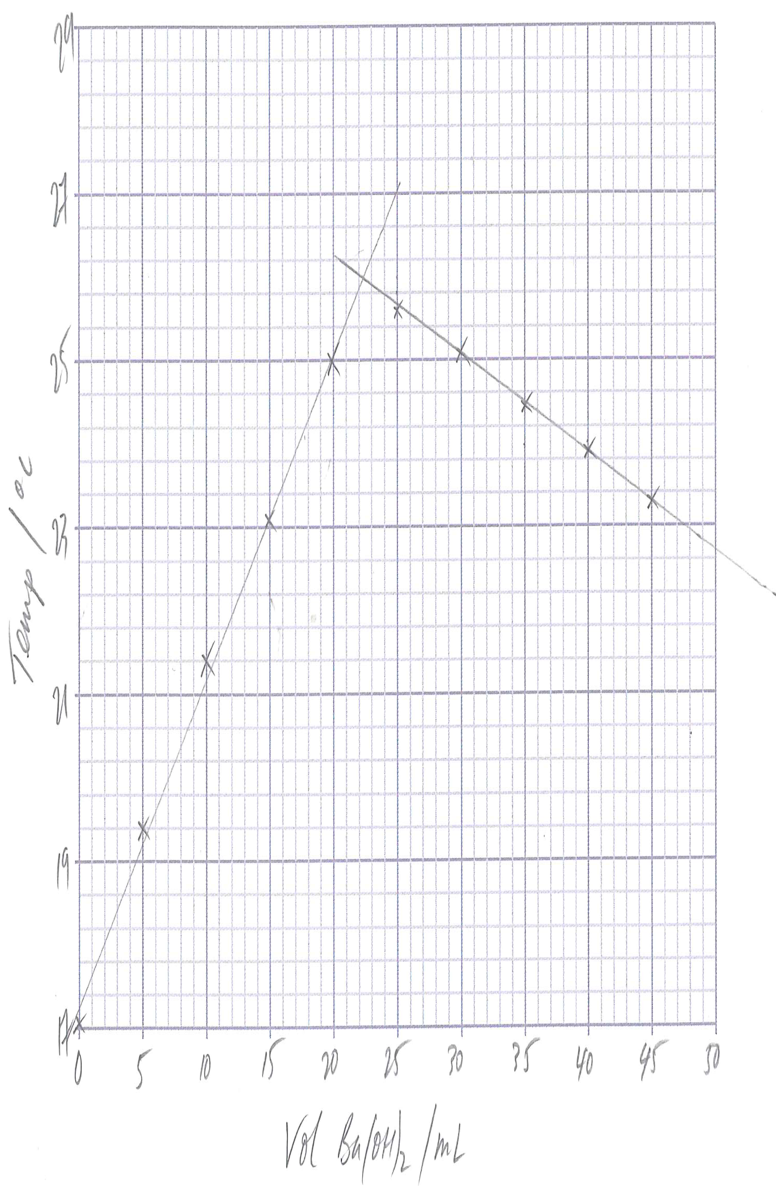

Estimated Volume: 22.5 mL (accept 22 – 23 mL) ✔

Axes correctly labeled, with units, and independent variable (volume of Ba(OH)₂ on x-axis ✔
Sensible linear scales chosen ✔
Points correctly plotted ✔
Best fit-lines drawn ✔
The experiment was repeated using phenolphthalein as an indicator to judge when the acid had been neutralised. A conical flask was rinsed with the acid, 0.296 g of the acid was placed in the flask, and a few drops of indicator were added. The solution was titrated using 0.123 mol L⁻¹ barium hydroxide solution from a burette, and 16.3 mL of the alkali was needed to reach equivalence.

- Use the data from the second experiment to calculate the molar mass of the acid and the value of n in the formula C_{n}H_{2n + 1}COOH. (6 marks)

n(Ba(OH)₂) = cv = 0.123 x 0.0163 = 2.00 x 10⁻³ mol ✔
n(acid) = 2 x n(Ba(OH)₂) = 2 x 2.00 x 10⁻³ = 4.00 x 10⁻³ ✔
M = m/n = 0.296 / 4.00 x 10⁻³ = 73.8 ✔
“M” COOH = 44.018, so “M” of C_{n}H_{2n+1} = 73.8 -44.018 = 29.8 ✔
n(CH₂) = 29.8 – 1.008 = 28.772
so n = 28.772 / (12.01 + 1.008 x 2) ✔
n = 2 ✔

- Identify a source of systematic error in the second experiment, and explain what effect it would have on the calculated value of the molar mass of the acid. (3 marks)

Conical flask was rinsed with acid ✔
More base required than would have been needed for 0.296 g of acid ✔
M is smaller, since M = m/n and n will now be larger than it should be ✔

Phenolphthalein is colourless in acidic solutions and pink in basic solutions, and changes colour at a pH of 8.2 – 10.0.

- Use a relevant equation to explain why phenolphthalein was a suitable choice of indicator for this titration. (3 marks)

Since C_{n}H_{2n+1}COOH is weak, its conjugate base, which is present in the salt, will react with water ✔
C_{n}H_{2n+1}COO⁻ + H₂O $⇌$ C_{n}H_{2n+1}COOH + OH⁻ ✔
Presence of OH⁻ ions shows solution is basic at equivalence, and we need an indicator that changes colour in the basic range ✔

Question 37 (14 marks)

Hair dyes often involve chemicals, such as hydrogen peroxide, which lighten the hair, combined with other substances, known as dye couplers, which serve to colour the hair once it has been lightened. One such dye coupler, used to provide yellow-green colours is known as
4-chlororesorcinol. Analysis of 4-chlororesorcinol has shown that it is composed of the elements carbon, hydrogen, oxygen and chlorine only.

In a series of experiments to determine the structure of 4-chlororesorcinol, a 0.725 g sample was combusted in excess oxygen. Upon analysis, the products of combustion were found to contain 1.326 g of carbon dioxide and 0.226 g of water vapour.

A second sample of 4-chlororesorcinol weighing 0.339 g was reacted with sodium metal. The products of this reaction were dissolved in water and the solution mixed with aqueous silver nitrate in order to precipitate the chloride ions. The precipitate was washed and dried, and found to weigh 0.336 g.

- Use the information provided to calculate the empirical formula of 4-chlororesorcinol.
(10 marks)

n(C) = n(CO₂) = 1.326 / 44.01 = 0.0301 mol ✔
n(H) = 2 x n(H₂O) = 2 x 0.226 / 18.016 = 0.0251 mol ✔

m(C) in 0.725 g sample = 0.0301 x 12.01 = 0.362 g
m(H) in 0.725 g sample = 0.0251 x 1.008 = 0.0253 g ✔

n(C) in 0.339 g sample = n(AgC) ✔
n(AgC) = 0.336 / 143.35 = 2.34 x 10⁻³ mol ✔

n(C) in 0.725 g sample = 2.34 x 10⁻³ x 0.725 / 0.339 = 5.01 x 10⁻³ mol
m(C) in 0.725 g sample = 5.01 x 10⁻³ x 35.45 = 0.178 g ✔

m(O) in 0.725 g sample = 0.725 – 0.362 – 0.0253 – 0.178 = 0.160 g ✔
n(O) in 0.725 g sample = 1.00 x 10⁻² mol ✔
C : H : O : C = 0.0301 : 0.0251 : 1.00 x 10⁻² : 5.01 x10⁻³ = 6 : 5 : 2 : 1 ✔
Empirical formula is C₆H₅O₂C ✔

A further 2.34 g sample of 4-chlororesorcinol was heated in an inert atmosphere. The vapour was found to occupy 560 mL at 150°C and 101.3 kPa.

- Use this information to calculate the molecular formula of 4-chlororesorcinol. (3 marks)

pV = nRT, so n = pV/RT
M = m/n = mRT/PV = 2.34 x 8.314 x 423.15 / (101.3 x 0.560) = 145.1 ✔
“M” (EF) = 6 x 12.01 + 5 x 1.008 + 2 x 16 + 35.45 = 144.55
M / “M” (EF) $≃$ 1 ✔
So MF = EF = C₆H₅O₂C ✔

- Explain what effect there would have been on the calculated amount of chlorine in the compound if the precipitate had not been washed and dried before weighing. (1 mark)

The amount of chlorine would have been larger since the precipitate’s mass would have been artificially high (sensible reason must be given to award mark)
Question 38 (14 marks)

Ethanol is an essential feedstock to the chemical industry, but its most common use today is as a fuel and a fuel additive. As the global supply of fossil fuels has diminished, ethanol has begun to be used as an alternative to petrol in combustion engines, although most cars cannot use pure ethanol without being modified.

Fermentative production, where glucose is turned into ethanol and carbon dioxide in a reaction catalyzed by yeast, is the most popular means of production of fuel ethanol. The glucose it uses is renewable, since it is obtained from crops such as corn and sugar cane.

Another common method of producing ethanol involves the catalytic hydration of ethene. This process is carried out on an industrial scale by mixing ethene (obtained from crude oil) and water vapour, which react according to the following equation:

C₂H₄(g) + H₂O(g) $⇌$ C₂H₅OH(g) ΔH = -45 kJ mol⁻¹

The reaction is carried out at a temperature of approximately 300°C and a pressure of approximately 70 atm (1 atm = 101.3 kPa) in the presence of a solid acid catalyst (usually phosphoric acid on solid silica). These conditions give a yield of approximately 5% ethanol. The ethanol that forms is removed from the system by cooling the mixture of gases, and any unreacted ethene is pumped back into the reaction vessel.

Using an understanding of collision theory and Le Chatelier’s principle where appropriate, discuss the conditions used in the catalytic hydration of ethene. Your answer should address the following points:

- The temperature and pressure at which the reactions are carried out
- The use of a catalyst
- The removal of ethanol from the mixture
- The recycling of the unreacted gases into the system

Temperature is a compromise between rate and yield ✔
High temperature increases rate because a greater % of particles have $≥$ E_{a} ✔
Therefore more successful collisions take place per unit time ✔
Low temperature favours forward reaction ✔
Because it is exothermic ✔
High pressure increases rate and yield ✔
More particles per unit volume ✔
Hence more frequent collisions ✔
Favours forward reaction since there are more particles colliding in forward direction ✔
Catalyst provides an alternative reaction pathway ✔
Which has a lower E_{a} ✔
Removal of products and recycling reactants increases yield ✔
Greater % of particles have enough energy to react, increasing rate ✔
Removing ethanol lowers [ethanol], meaning fewer ethanol molecules per unit volume ✔
Rate of backward reaction slowed (since fewer collisions per unit time) in relation to forward reaction ✔
Pumping reactants back into system increases [reactants], hence more reactant molecules per unit volume ✔
Rate of forward reaction increases (so forward reaction is favoured), since more collisions per unit time ✔

Any 14 of the above points, made in a coherent order
Max 14
Question 39 (9 marks)

The element phosphorus exists as several allotropes, including diphosphorus, white phosphorus, red phosphorus, violet phosphorus and black phosphorus. White phosphorus will react with dilute solutions of copper(II) sulfate to deposit metallic copper and produce a highly acidic solution.

In an experiment to investigate this reaction, 0.372 g of white phosphorus reacted in an excess of aqueous copper(II) sulfate to produce 1.91 g of copper.

- Use this information to calculate the number of moles of copper deposited for each mole of phosphorus. (2 marks)

n(P) = 0.372 / 30.97 = 0.0120 mol
n(Cu) = 1.91 / 63.55 = 0.0301 mol ✔
Cu : P = 0.0301 : 0.0120 = 1 : 2.50
So 2.5 moles of Cu per mole of P ✔

- Use the concept of oxidation numbers to show whether the copper is acting as a reductant or an oxidant in this process. (2 marks)

Cu goes from +2 (in Cu²⁺) to 0 (in Cu), so it has been reduced ✔
The species that gets reduced is the oxidant ✔

- Calculate the change in the oxidation number of phosphorus in the reaction. (3 marks)

2 mol of e⁻ per mol of Cu, so 2.5 mol requires 5 mol of e⁻ ✔
Therefore each mol of P LOST 5 mol of e⁻ ✔
P starts as 0, so goes to +5 ✔
- In the reaction, the phosphorus forms an acid with the formula HPO_{x}. Use your answer to part (c) to determine the value of x. (2 marks)

Oxidation numbers of P (+5) and H (+1) add to +6 ✔
O will have an oxidation number of -2, so 2x = -6, and x = 3 ✔

Question 40 (16 marks)

The enthalpy of combustion of a substance, ΔH_{c}, is defined as the enthalpy change when 1 mole of a substance is burned completely in excess oxygen. The enthalpies of combustion of the first four alkanes are shown in the table below.

Name of alkane | Enthalpy of combustion  (kJ mol⁻¹)
Methane | -890
Ethane | -1560
Propane | -2220
Butane | -2877

- Write a balanced equation for the complete combustion of methane in excess oxygen.
(2 marks)

CH₄ + O₂ CO₂ + 2 H₂O

Carbon dioxide and water shown as products ✔
Balanced ✔
- Using the axes provided below, sketch a reaction profile for the complete combustion of methane, assuming the activation energy is 2650 kJ mol⁻¹. You should ensure that you draw your diagram approximately to scale, and label clearly the reactants, products, the enthalpy change, and the activation energy. (4 marks)

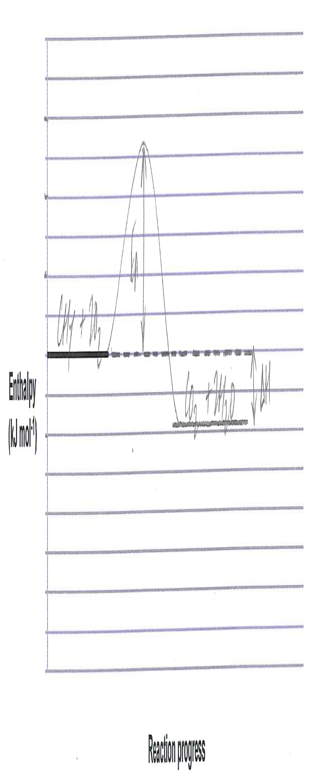
E_{a} correctly labeled ✔
ΔH correctly labeled ✔
Products at lower enthalpy than reactants ✔
E_{a} and ΔH correct sizes relative to one another ✔

A typical Bunsen burner set on a roaring flame operating in a laboratory at 20°C burns 0.0800 L of natural gas per second, measured at 101.5 kPa. Natural gas is composed of 95% methane, with the other 5% being made up of small amounts of ethane, propane, butane and hydrogen sulfide, as well as some nitrogen and carbon dioxide.

- Calculate the number of moles of methane burnt when a Bunsen burner is used to heat a beaker of water for five minutes. (1 mark)

n = pV/RT = 300 x (101.5 x 0.0800 / (8.314 x 293.15)) x 0.95
= 0.950 mol ✔

A roaring Bunsen flame will burn at approximately 700°C.

- Calculate the volume of the exhaust gases produced at this temperature during the five minutes. You may assume that the pressure of the laboratory in unaffected by the Bunsen burner. (2 marks)

n(exhaust gases) = 3 x n(methane) ✔
V = nRT/P = 3 x 0.950 x 8.314 x 973.15 / 101.5 = 227 L ✔

Alkanes will react with chlorine gas in the presence of bright UV light.

- Give the name of this type of reaction. (1 mark)

(Radical) Substitution

- Give the name of a possible organic product formed when propane reacts with chlorine in the presence of bright UV light. (1 mark)

1-chloropropane, 2-chloropropane (do not allow C₃H₇C)
Allow poly-substituted products, as well as hexane, etc. if correctly named

Another substance commonly found in natural gas is hydrogen sulfide. When this is heated in the presence of oxygen it can also combust, forming an oxide of sulfur in which sulfur has an oxidation number of +4. Water is also formed in the reaction.

2 H₂S + 3 O₂ 2 SO₂ + 2 H₂O

Correct species ✔
Balanced ✔
- Write a balanced equation for the reaction between hydrogen sulfide and oxygen to form sulfur dioxide and water. (2 marks)

The sulfur dioxide formed in this process is known to cause acid rain when it is released into the Earth’s atmosphere.

- With the help of equations, explain how sulfur dioxide is able to cause the acidification of rain water. (3 marks)

Sulfur dioxide reacts with water to form sulfurous acid, which ionizes in water to produce H⁺ (or H₃O⁺) ions ✔
SO₂ + H₂O H₂SO₃ ✔
H₂SO₃ + H₂O $⇌$ HSO₃⁻ + H₃O⁺ (or H₂SO₃ $⇌$ HSO₃⁻ + H⁺) ✔

End of questions

